**SPLIT THE COLUMN USING DELIMITER:**

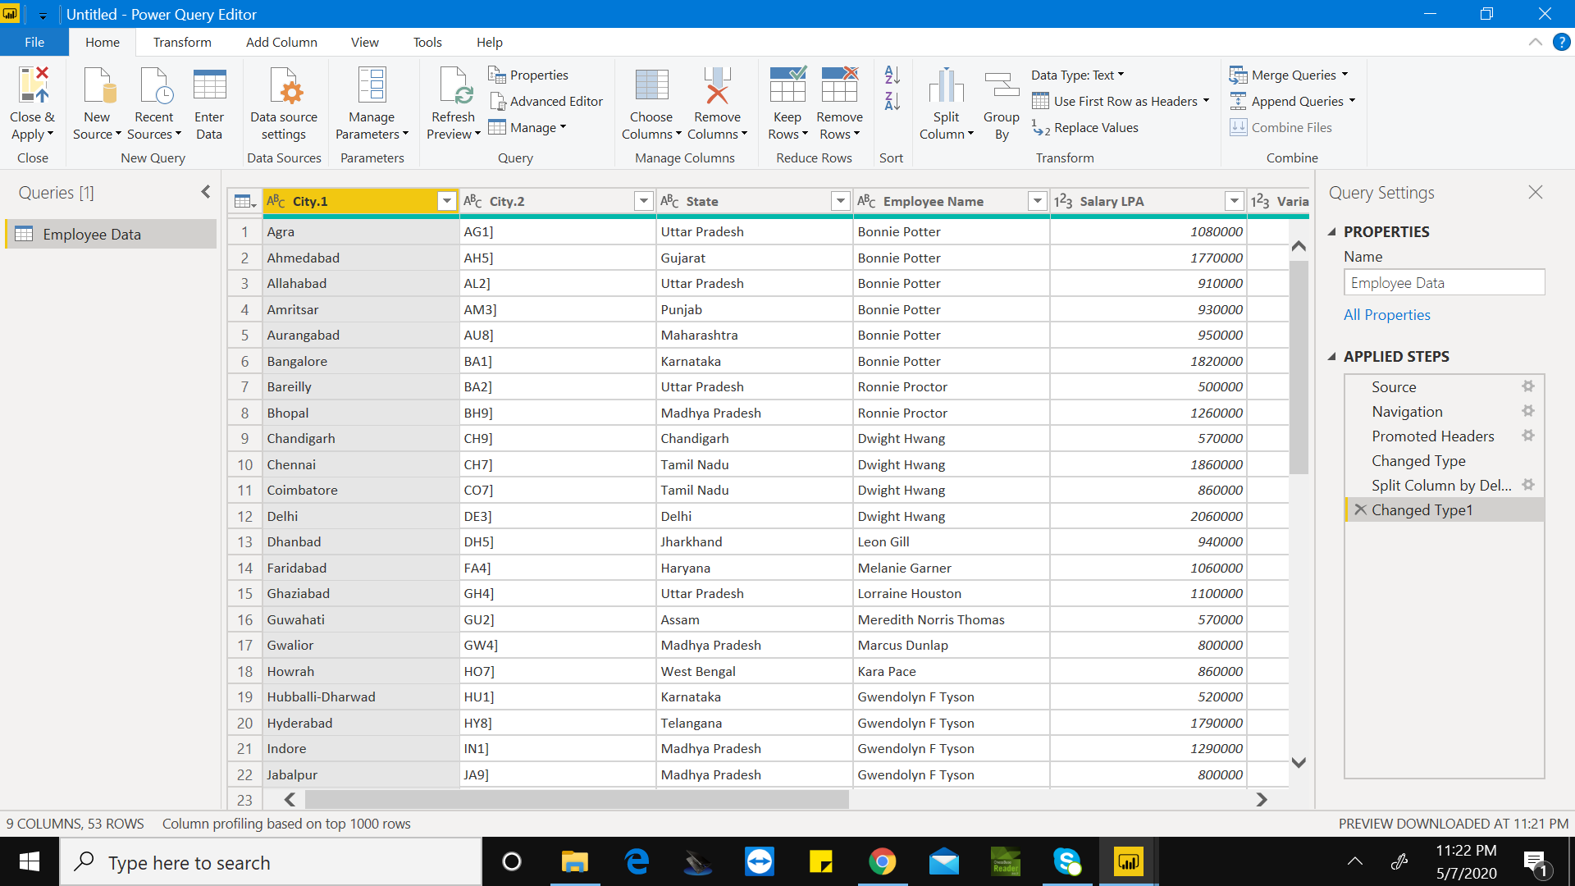

**EXTRACT THE EMPLOYEE FIRST NAME AND TRANSFORM THE COLUMN:**

**USING DELIMITER**

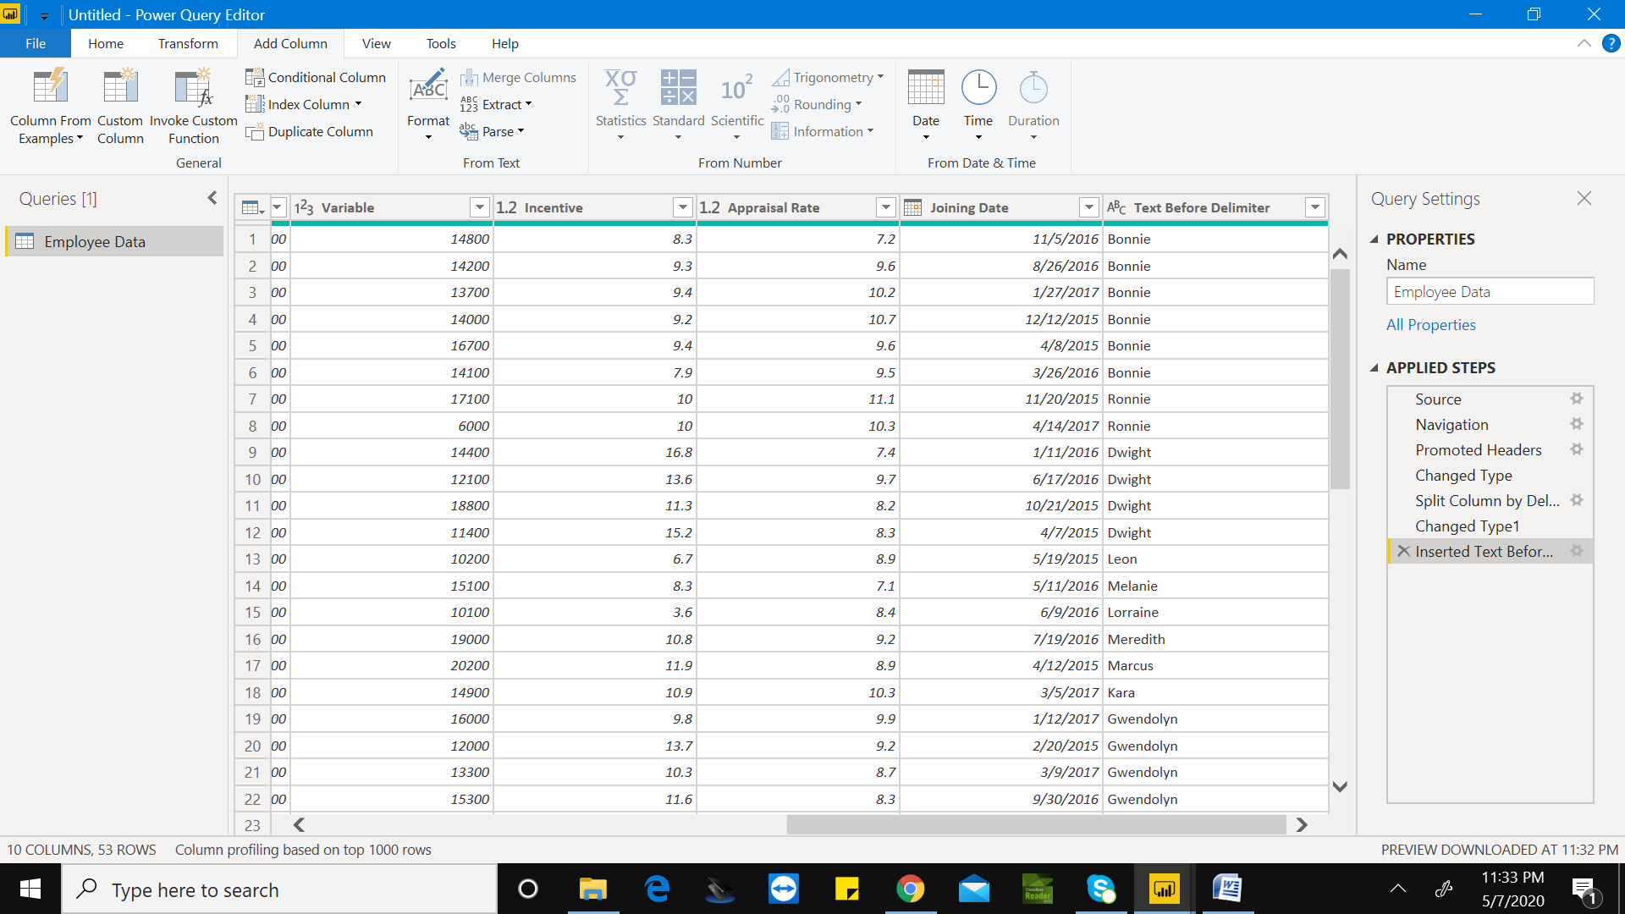

**EXTRACT YEAR AND NUMBER OF DAYS IN THAT MONTH:**

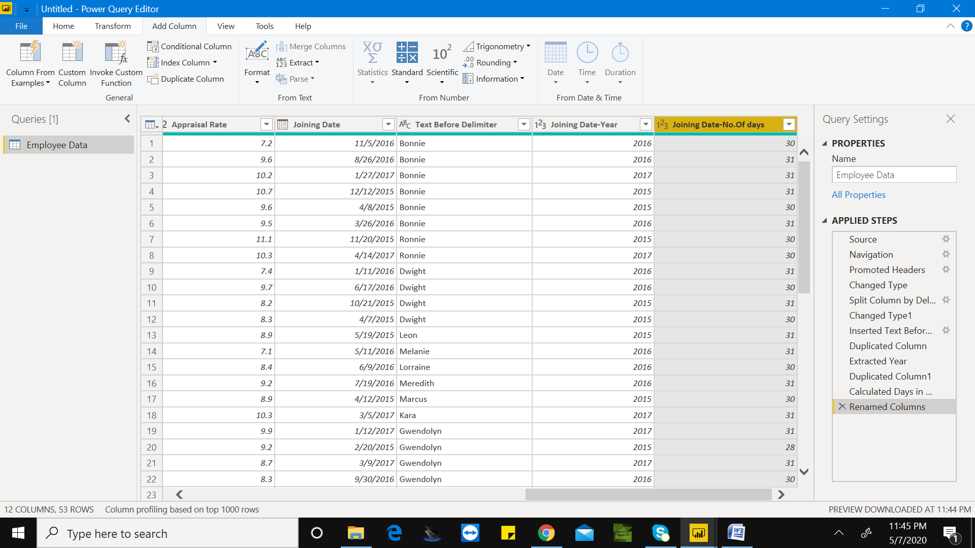

**PIECHART FOR SALARY IN TERMS OF STATE:**

**ASSAM AND CHANDIGARH HAS LOWEST SALARY:**

